Access Certification Implementation Report

1. Introduction
Access Certification (also known as access attestation) is a governance process used to periodically review user access rights and ensure they align with business roles and responsibilities.
It is a key requirement in compliance frameworks and helps organizations maintain security and accountability.

2. Objective
- Validate user access permissions
- Identify excessive or unnecessary access
- Enforce least privilege principles
- Generate audit-ready documentation

3. Tools Used
- Microsoft Entra ID
- Azure Portal
- Microsoft Excel (Manual Certification Tracking)

4. Implementation Steps

4.1 Data Collection
User and access data were exported from Microsoft Entra ID.

4.2 Certification Setup
A certification sheet was created to track user access and review decisions.
Columns included:
- User Name
- Role
- Access Type
- Reviewer
- Decision
- Comments
- Status
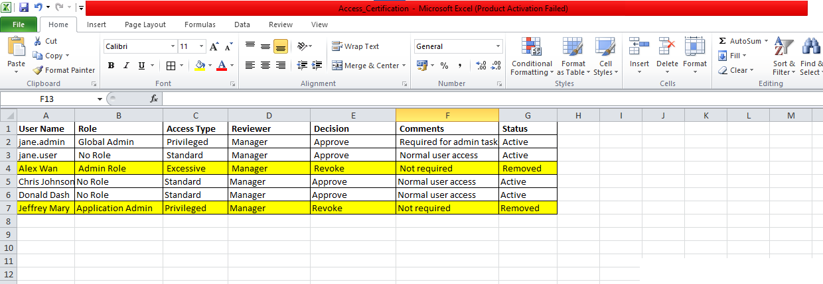
Certification-sheet.png

4.3 Access Review
Each user’s access was evaluated against expected roles.
Findings:
- jane.admin → Valid privileged access ✔
- jane.user → Standard access ✔
- test.user → Excessive access ❌

4.4 Decision & Approval
Access decisions were recorded:
- Approve → Valid access
- Revoke → Unnecessary access

4.5 Remediation
Unnecessary access was removed by revoking roles or disabling accounts.
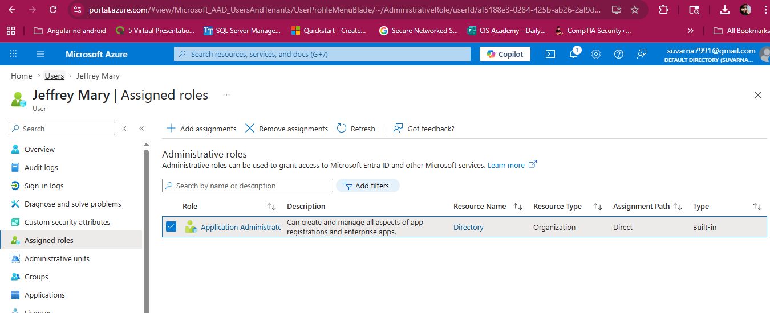
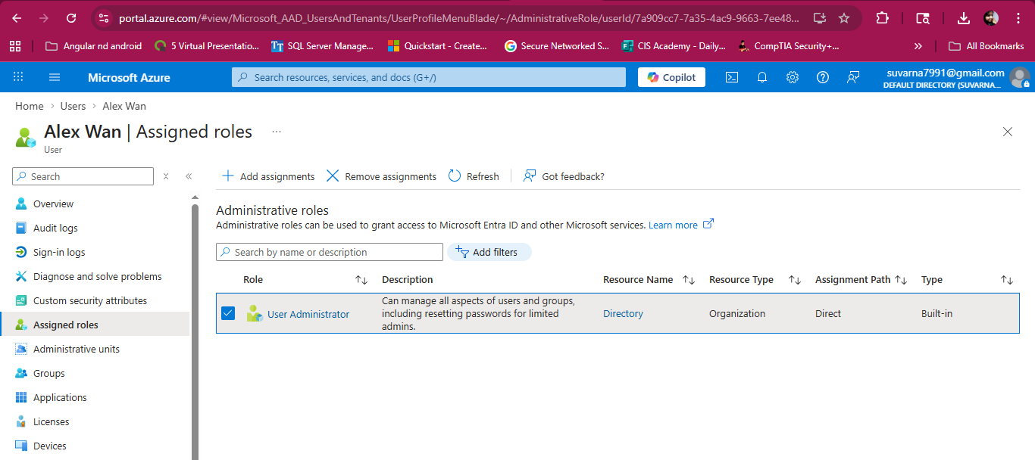
certification-before.png
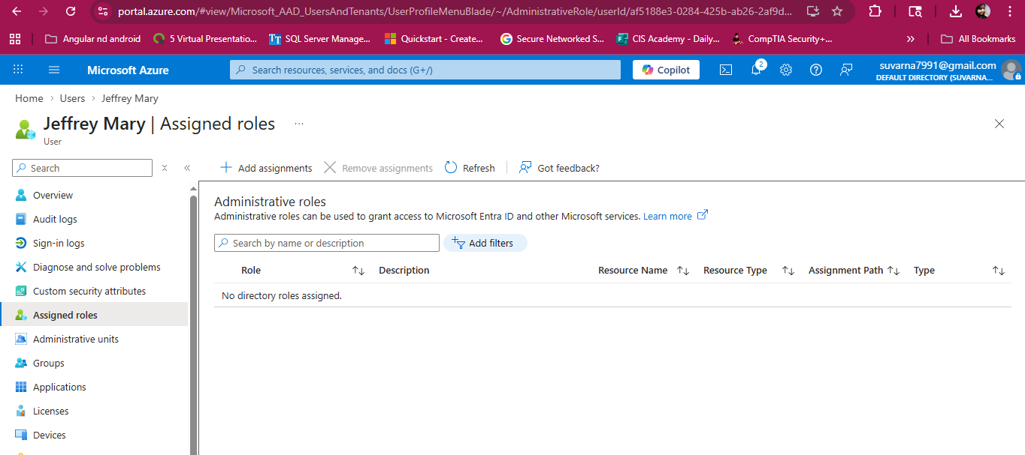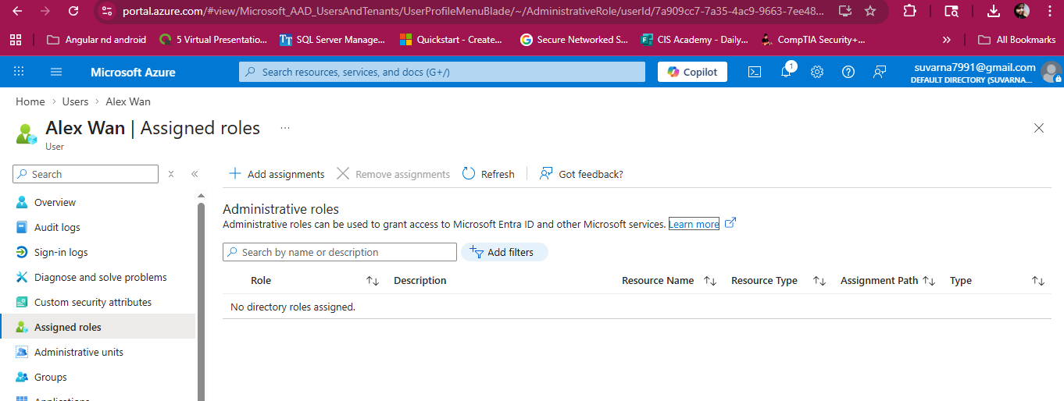
certification-after.png

4.6 Audit Validation
All changes were verified using audit logs in Entra ID.
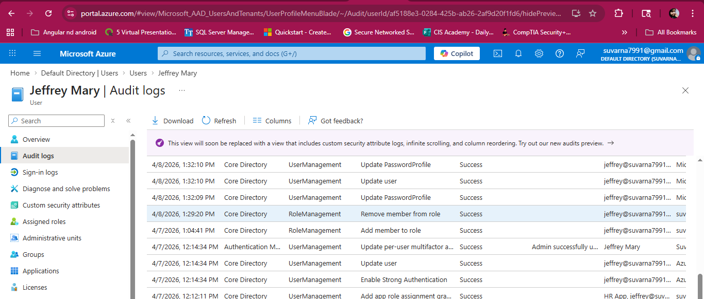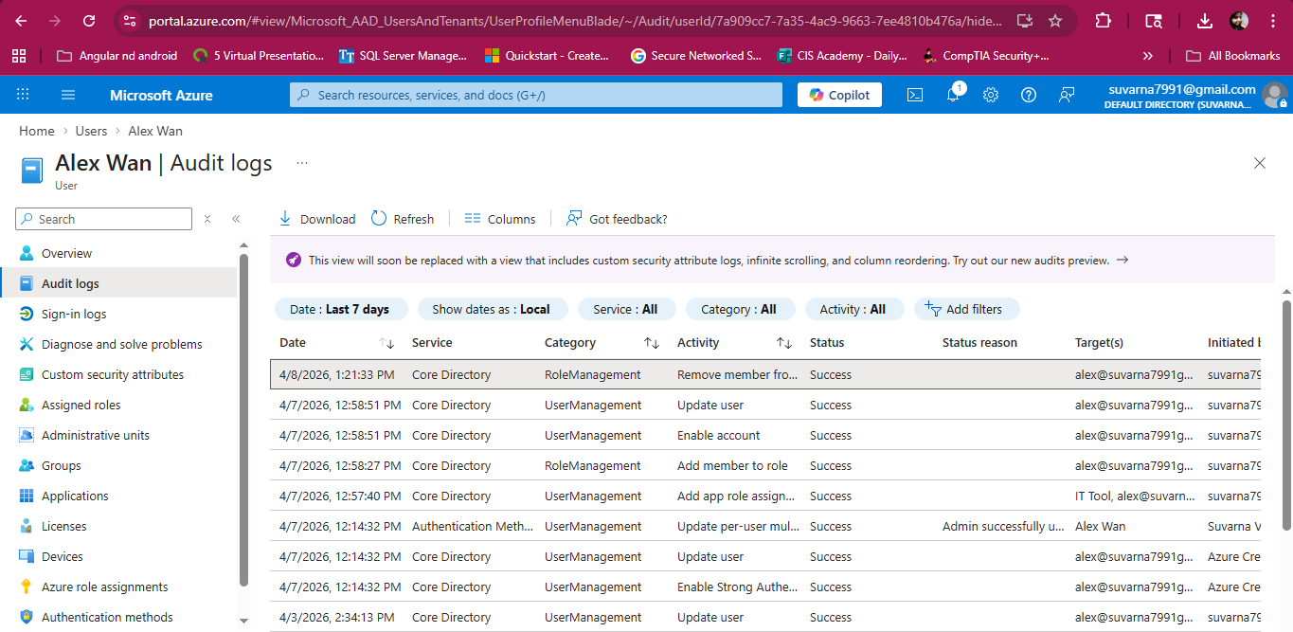

5. Security Controls Implemented
- Access certification process
- Least privilege enforcement
- Role validation
- Audit logging and monitoring

6. Key Learnings
- Importance of periodic access reviews
- Governance in IAM environments
- Identifying and removing excessive access
- Preparing audit-ready documentation

7. Enterprise Mapping
In enterprise IAM tools such as SailPoint and Saviynt:
- Certification campaigns are automated
- Reviewers approve/reject access
- Notifications and escalations are triggered
This project simulates the same workflow manually using Entra ID and Excel.

8. Conclusion
The access certification process successfully validated user permissions, removed excessive access, and produced audit-ready evidence.
This aligns with real-world IAM governance practices used in enterprise environments.

